**三宮殿**

**平面圖**

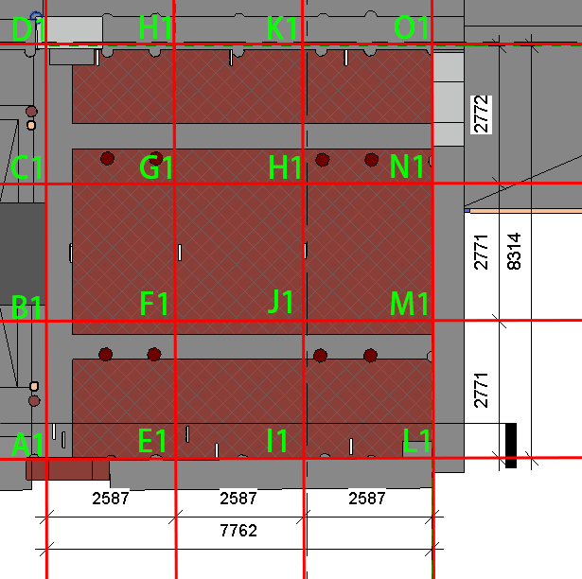

**一點透視**

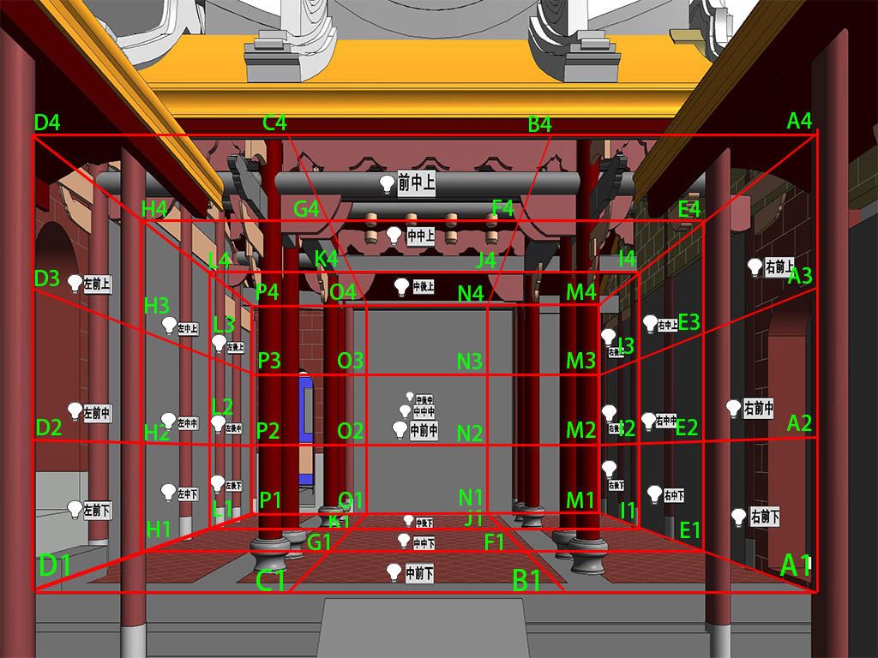

|  |  |  |  |
| --- | --- | --- | --- |
| 點位 | N | E | Z |
| A1 | -13677.7 | 2262.6 | 769 |
| B1 | -10906.7 | 2262.6 | 769 |
| C1 | -8135.7 | 2262.6 | 769 |
| D1 | -5363.3 | 2262.6 | 769 |
| E1 | -13677.7 | 4849.6 | 769 |
| F1 | -10906.7 | 4849.6 | 769 |
| G1 | -8135.7 | 4849.6 | 769 |
| H1 | -5363 | 4849.6 | 769 |
| I1 | -13677.7 | 7436.6 | 769 |
| J1 | -10906.7 | 7436.6 | 769 |
| K1 | -8135.7 | 7436.6 | 769 |
| L1 | -5363 | 7436.6 | 769 |
| M1 | -13677.7 | 10025.1 | 769 |
| N1 | -10906.7 | 10025.1 | 769 |
| O1 | -8135.7 | 10025.1 | 769 |
| P1 | -5363.3 | 10025.1 | 769 |

|  |  |  |  |
| --- | --- | --- | --- |
| 點位 | N | E | Z |
| A2 | -13677.7 | 2262.6 | 1829 |
| B2 | -10906.7 | 2262.6 | 1829 |
| C2 | -8135.7 | 2262.6 | 1829 |
| D2 | -5363.3 | 2262.6 | 1829 |
| E2 | -13677.7 | 4849.6 | 1829 |
| F2 | -10906.7 | 4849.6 | 1829 |
| G2 | -8135.7 | 4849.6 | 1829 |
| H2 | -5363 | 4849.6 | 1829 |
| I2 | -13677.7 | 7436.6 | 1829 |
| J2 | -10906.7 | 7436.6 | 1829 |
| K2 | -8135.7 | 7436.6 | 1829 |
| L2 | -5363 | 7436.6 | 1829 |
| M2 | -13677.7 | 10025.1 | 1829 |
| N2 | -10906.7 | 10025.1 | 1829 |
| O2 | -8135.7 | 10025.1 | 1829 |
| P2 | -5363.3 | 10025.1 | 1829 |

|  |  |  |  |
| --- | --- | --- | --- |
| 點位 | N | E | Z |
| A3 | -13677.7 | 2262.6 | 2889 |
| B3 | -10906.7 | 2262.6 | 2889 |
| C3 | -8135.7 | 2262.6 | 2889 |
| D3 | -5363.3 | 2262.6 | 2889 |
| E3 | -13677.7 | 4849.6 | 2889 |
| F3 | -10906.7 | 4849.6 | 2889 |
| G3 | -8135.7 | 4849.6 | 2889 |
| H3 | -5363 | 4849.6 | 2889 |
| I3 | -13677.7 | 7436.6 | 2889 |
| J3 | -10906.7 | 7436.6 | 2889 |
| K3 | -8135.7 | 7436.6 | 2889 |
| L3 | -5363 | 7436.6 | 2889 |
| M3 | -13677.7 | 10025.1 | 2889 |
| N3 | -10906.7 | 10025.1 | 2889 |
| O3 | -8135.7 | 10025.1 | 2889 |
| P3 | -5363.3 | 10025.1 | 2889 |

|  |  |  |  |
| --- | --- | --- | --- |
| 點位 | N | E | Z |
| A4 | -13677.7 | 2262.6 | 3949 |
| B4 | -10906.7 | 2262.6 | 3949 |
| C4 | -8135.7 | 2262.6 | 3949 |
| D4 | -5363.3 | 2262.6 | 3949 |
| E4 | -13677.7 | 4849.6 | 3949 |
| F4 | -10906.7 | 4849.6 | 3949 |
| G4 | -8135.7 | 4849.6 | 3949 |
| H4 | -5363 | 4849.6 | 3949 |
| I4 | -13677.7 | 7436.6 | 3949 |
| J4 | -10906.7 | 7436.6 | 3949 |
| K4 | -8135.7 | 7436.6 | 3949 |
| L4 | -5363 | 7436.6 | 3949 |
| M4 | -13677.7 | 10025.1 | 3949 |
| N4 | -10906.7 | 10025.1 | 3949 |
| O4 | -8135.7 | 10025.1 | 3949 |
| P4 | -5363.3 | 10025.1 | 3949 |